***Universidad Europea de Madrid***

***Aerodynamics and Aeroelasticity***

***Homework 1***

***Jan. 30th 2017***

***Problem1***

Find the value of the line integral $\oint_{A}^{B}{F}ds$ where F is a vector field F $(r)=[ -y, -xy]= -y\check{i}-xy\check{j}$ and C is the circular arc from A to B as shown on figure.

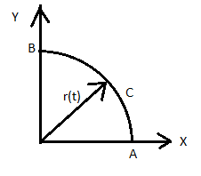

***Problem 2***

**Part 1:** Apply the momentum equation to determine the drag of the airfoil that is shown

in below figure. Consider the control volume abcdefghia the width of the control

volume in direction of z is unity. Stations 1 and 2 are inflow and outflow

respectively. Assume that the contour abhi is far enough from the airfoil such

that the pressure is everywhere the same on abhi and equal to the freestream

pressure P∞ .State your assumptions.

**Part 2:** How do you determine the lift force of the airfoil? Only explain.

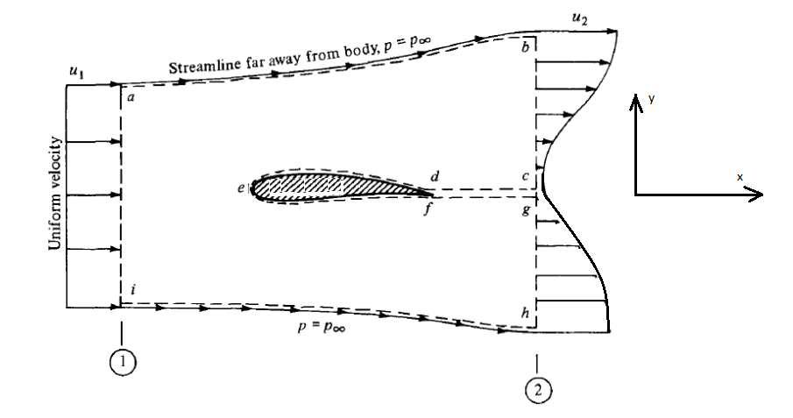

***Problem 3***

In low speed and incompressible flow, we measure a NACA 4412 profile with an angle of attack of 4, and we obtain: cl=0.85 Cm c/4=-0.09. Calculate the location of the center of pressure.

***Problem 4***

Consider the DC3, Just outboard of the engine nacelle, the airfoil chord length is 4.6m. At cruising velocity 300km/h at sea level, the moment per unit span at this airfoil location is M´(c/4) = -4850N.m/m and M´LE =-14550N.m/m . Calculate the lift per unit span and the location of the center of pressure.

***Problem 5***

Consider an incompressible flow, laminar boundary layer growing along the surface flat plate with chord of length C. Assuming velocity profile through the boundary layer is given by:

$u={v_{∞ }\left(\frac{y}{δ}\right)}^{1/5}$

Where $δ$ is the thickness of boundary layer.



Calculate the coefficient of skin friction. Hint use the expression of Drag obtained in problem 2 part 1.