Lab 4
More Programming Practice:
Image Transformation

MIPSfpga Lab 4:
Image Transformation

Image transformation

4.1 Introduction
The aim of this exercise is to perform the transformation of an image with three color channels (RGB) to a grayscale image, and then transform it into a binary image. Figure 1 shows the result of this process on an example image.
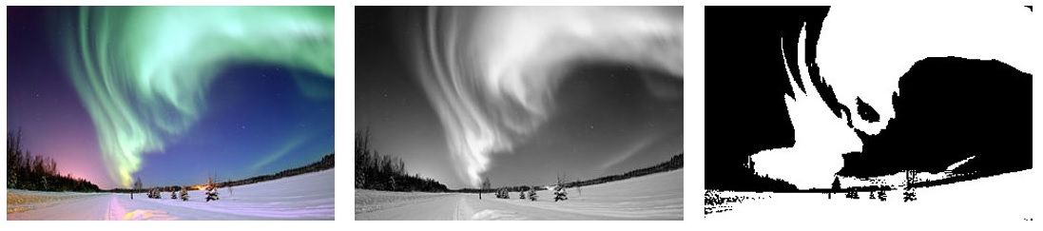
Figure 1. Example image in color, grayscale and binary
Folder Part1_Intro\Lab04_MoreProgramming\ImageTransformation provides the source code for this exercise, with some empty functions that you have to complete as explained below.
An image is usually represented as a matrix, where each element of the matrix stores the value of a pixel within the image. In RGB, each pixel is defined by three values: level of red (R), level of green (G) and level of blue (B). Therefore, each element of the color image is represented with a vector of 3 elements. Specifically, for this lab, we use the following definition for a pixel in the RGB image (see file Part1_Intro\Lab04_MoreProgramming\ImageTransformation\trafo.c):
typedef struct _pixel_RGB_t{
unsigned char R;
unsigned char G;
unsigned char B;
} pixelRGB;

Note that, in this definition, each color channel uses 8 bits, thus each channel can represent 256 different values, and we have a total of 24 bits per pixel (24bpp).
In the case of a grayscale image, a single value is used to represent the brightness of each pixel, and in the case of a binary image, a single bit is necessary. In this lab, we use 8 bits to represent each pixel on both a grayscale and a binary image.
The following code defines three 128x128 images: an RGB image, a grayscale image and a binary image (see file Part1_Intro\Lab04_MoreProgramming\ImageTransformation\main.c).
#define NROWS 128
#define NCOLS 128

pixelRGB ColorImage[NROWS*NCOLS];

unsigned char GrayImage[NROWS*NCOLS];

unsigned char BinaryImage[NROWS*NCOLS];

As an example, in order to access the pixel located at row 13 and column 24, you must index the images as follows:
RGB Image:
ColorImage[13*NCOLS + 24].R
ColorImage[13*NCOLS + 24].G
ColorImage[13*NCOLS + 24].B

Grayscale Image:
GrayImage[13*NCOLS + 24]

Transformation of an image from RGB to grayscale
In order to transform the RGB image into a grayscale image (function RGB2GrayMatrix in file Part1_Intro\Lab04_MoreProgramming\ImageTransformation\trafo.c) we perform a simple linear function, as shown in Figure 2. Thus, in your C program, you have to include the following command:
GrayImage[x*NC+y] = 0.2126*RGBImage[x*NC+y].R + 0.7152*RGBImage[x*NC+y].G + 0.0722*RGBImage[x*NC+y].B;

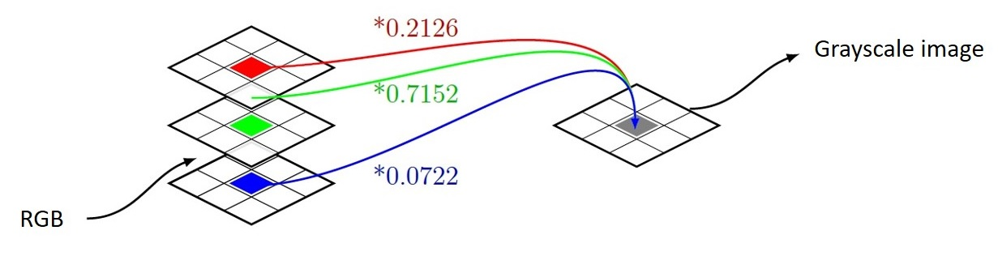
Figure 2. Example image in color, grayscale and binary.
Note that, in this equation, we need to perform floating point operations. However, the processor configuration that we are using in MIPSfpga does not include a floating point unit. Thus, you will transform the previous equation into integer arithmetic (see function rgb2gray in file Part1_Intro\Lab04_MoreProgramming\ImageTransformation\trafo.c):
GrayImage[x*NC+y] = (3483*RGBImage[x*NC+y].R + 11718*RGBImage[x*NC+y].G + 1183*RGBImage[x*NC+y].B) / 16384;

Transformation of an image from grayscale to binary
The algorithms used for transforming an image from grayscale into binary format use to compare each pixel with a threshold: if the value is higher than the threshold, the pixel in the binary image is set to white (1), otherwise, it is set to black (0). Function Gray2BinaryMatrix in file Part1_Intro\Lab04_MoreProgramming\ImageTransformation\trafo.c implements this functionality.
For selecting the threshold value you could use different techniques. In this lab, you will first create a function (called computeHistogram and defined in file Part1_Intro\Lab04_MoreProgramming\ImageTransformation\trafo.c) which builds a histogram that accounts for the number of occurrences of each of the 256 possible values of light intensity (you can use the following array: short int histogram[256];). Then, function computeThreshold looks for the index of the maximum value in the first 128 elements (let´s call it i) and the index of the maximum value in the 128 second elements (let´s call it j), and calculates the threshold as follows:
Threshold = i + (j - i)/2

Exercise
The aim of this lab is to develop the transformations explained in the previous section in C and assembly languages, execute them on the board, and check the resulting images. We next describe the files that compose the project available in folder Part1_Intro\Lab04_MoreProgramming\ImageTransformation:
- main.c: In this file we define the images and invoke the functions that implement the image transformations. If LENA is defined, the RGB image is initialized with a 128*128 image widely used since the early works on image editing. If the image is not defined, a synthetic image is used. After the images are defined and initialized, the main function invokes the different functions for performing the RGB to grayscale and grayscale to binary transformations.
- lena128color.h: This file contains 128*128*3 values representing the R, G and B channels of each of the 128*128 pixels that make up Lenna image.
- trafo.c: This file contains the functions for performing the transformations, most of which you have to implement. Specifically:
  - RGB2GrayMatrix: This function performs RGB to grayscale image transformation as explained above and is already implemented. It invokes function rgb2gray, also described in the previous section, which you have to complete.
  - computeHistogram: As explained above, this function must compute the histogram. You also have to complete this function.
  - computeThreshold: In this function the threshold is computed as described in the previous section. You also have to complete this function.
  - Gray2BinaryMatrix: Using the threshold computed in the previous function, the grayscale image is transformed into a binary image. You also have to complete this function.
Once you have implemented all these functions in C language, you can compile, run and visualize the results by following the next steps:
- Download MIPSfpga on the board as explained in Step 1 – Lab 2.
- Compile the project as explained in Step 2 – Lab 2.
- Download the project onto the MIPSfpga system as explained in Step 3 – Lab 2.
- Debug the project as explained in Step 4 – Lab 2. Specifically, run the following commands in gdb:
  - monitor reset halt
  - b *0x800002dc (set a breakpoint after returning from the last function invoked at main.c, which is Gray2BinaryMatrix; note that it can be placed in a different address to the one used here)
  - c
Execution should start and stop after returning from function Gray2BinaryMatrix. At this point, run in gdb the following commands, which will create two files containing the pixels of the grayscale and binary images:
  - dump value gray.dat GrayImage
  - dump value binary.dat BinaryImage
- These files are not in any common image format, but can be easily converted. For that purpose, you can use the file provided in Part1_Intro\Lab04_MoreProgramming\ImageTransformation\dump2ppm.c. Compile that file and execute it as follows:
  - dump2ppm gray.dat gray.ppm 128 128 1
  - dump2ppm binary.dat binary.ppm 128 128 1
You should now be able to visualize the .ppm images (if you don´t have an application that can read this format, such as gimp, transform the .ppm image into a format that you can visualize).
Finally, as another interesting exercise, you can implement some of the functions performing the image transformations in MIPS assembly language. As an example, you can start by programming function rgb2gray in MIPS assembly language. For that purpose:
- File assembly.c defines subroutine rgb2grayAssembly, which you have to complete in MIPS assembly language. In addition, complete subroutine div16K, which should be invoked from rgb2grayAssembly for computing the division by 16384. Make sure you meet the MIPS convention for managing function calls, explained in detail in Section 6.4.6 of [1]. Finally, in function RGB2GrayMatrix, change invocation of function rgb2gray for function rgb2grayAssembly.

References
[1] “Digital Design and Computer Architecture”, 2nd Edition. David Money Harris and Sarah L. Harris. Morgan Kaufmann, 2012.

