**Universidad Europea de Madrid**

Aerospace Engineering degree

Advanced Fluid Dynamic

Homework 4

Porous medium

**Problem 1**

If the velocity of groundwater between two wells is 3.4m per day and the hydraulic gradient between the two wells is .005, what is the hydraulic conductivity of the aquifer between the two wells (assuming it is homogenous throughout)?

**Problem 2**

An aquifer is 2045 wide and 28 m tall. Its hydraulic gradient is .05 and its hydraulic conductivity is 145m/day. Calculate the velocity of the groundwater as well as the amount of water that passes through the end of the aquifer its day if the porosity of the aquifer is 23%.

**Problem 3**

The equation of flow for steady‐state saturated flow is given by the Laplace equation. The equation expressed for the x y horizontal plane is



where h is hydraulic head. Subject to the specific boundary conditions an analytical solution exists. Consider the simple groundwater flow problem illustrated in the figure. The region ABCD contains a homogeneous, isotropic porous medium of hydraulic conductivity K. The boundaries AB and CD are impermeable; the hydraulic heads on AD and BC are h0 and h1 , respectively. The analytical solution is



If h0 =50m , h1 =100cm , xL = 5000m, and yL = 50m , determine the location(s) where hydraulic head values are equal to 50m, 60m, 70m and 90m.



**Problem 4**

Water at 20°C is flowing through the sand column shown in below figure (L=220cm, A=300cm2 , h1 –h2= 400cm, the sand in the column has a porosity equal to 0.35 and hydraulic conductivity K= 2.5m/d Determine

a) The rate of flow (Q) and the specific discharge(q)

b) The average velocity of flow in the column (v)

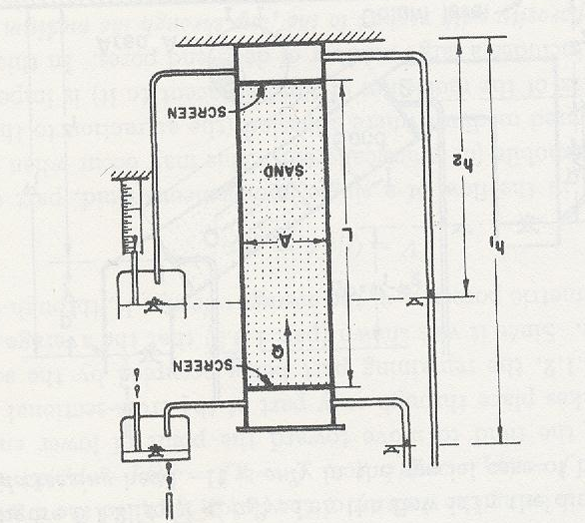

**Problem 5**

Polymer composite is composed by E glass and epoxy resin. The surface tension between untreated E-glass and epoxy resin is 3.5x10-4N/cm with contact angle of 60˚ the average distance between fibers is 0.00001cm. And the surface tension for treated E-glass and epoxy is 4.5x10-4 N/cm and the contact angle is reduced to 20˚. For both conditions determine the capillary pressure.

**Problem 6**

A pull-out test is performed to determine the interface between boron fiber and epoxy resin matrix. Fiber diameter is D=10μm, the maximum tensile strength is 2000MPa and the length of the monofilament fiber buried on the matrix is 760μm. Determine the average shear strength between the monofilament fiber and matrix. Repeat the calculations for a D=1μm