Fluid Mechanics II
Homework 3
Due on October 26, 2020

Problem 1
A non-porous inner cylinder of radius a rotates at ω, and the porous outer cylinder is fixed, there is radial component of the constant velocity in this wall, as shown in below figure. Assuming zero circumferential pressure gradient and (a-b)<<<a, the gravity effects are negligible derive formulas for velocity distribution.
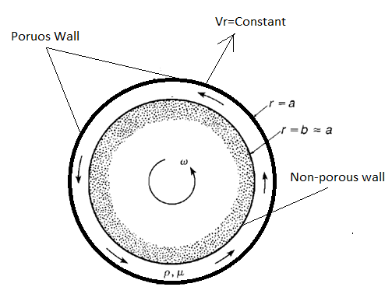
Problem 2
Based on the measurements shown in the table, calculate the gravimetric water content, volumetric water content, porosity, water saturation, bulk density, and dry bulk density.
Sample volume, cm³ | 25
Wet mass of sample, g | 43.5
Dried mass of sample, g | 39.75
Particle density, g cm⁻³ | 2.65
Problem 3
The equation of flow for steady‐state saturated flow is given by the Laplace equation. The equation expressed for the x y horizontal plane is

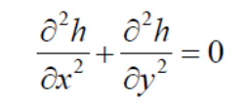

where h is hydraulic head. Subject to the specific boundary conditions an analytical solution exists. Consider the simple groundwater flow problem illustrated in the figure. The region ABCD contains a homogeneous, isotropic porous medium of hydraulic conductivity K. The boundaries AB and CD are impermeable; the
hydraulic heads on AD and BC are h₀ and h₁ , respectively. The analytical solution is

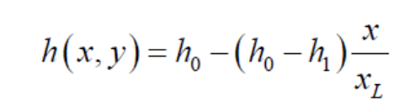
If h₀ =100m , h₁ =10m , x_{L} = 500m, and y_{L} = 100m , determine the location(s) where hydraulic head values are equal to 50m, 60m, 70m and 90..

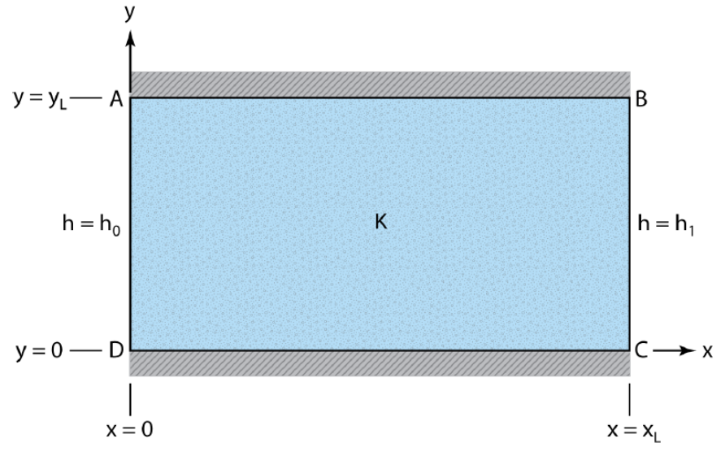

Problem 4
Navier-Stokes equations is applied in a Poiseuille flow in a capillary. The physicist Poiseuille, first proposed, studied the flow of blood by capillary, this study has a lot of impact on porous media research since the permeability according to the porosity can be estimated. Below figure shows the capillary tube. Determine the average velocity and total flow (q) through the capillary tube

